**P2 - Explain how different types of graphic images relate to file formats**

**Introduction**

In this assignment, I will be stating different types of graphic images that relate to file format. I am going to be naming the following:

* ***File handling*:** converting files; file sizes; file formats e.g. jpg, bmp; file management e.g. naming files, folder structures, moving files, deleting files; compression techniques
* ***Graphic images*:** vector graphics; bitmaps; comparison e.g. file size, scaling; file format features, typical uses

**File Handling**

**Converting Files**

Converting files is usually converted from one document to another e.g. PDF to document format. Files can be converted using many ways of format. They are programs available to convert files in any format and it can automatically convert a collection of files from one format to another. One you convert the document to another format, it may lose quality or be different from the previous format you may have put it in e.g. picture moved from previous spot.

**File Size**

File size depends on which format it is used. Each different format differs from each format. As you can see below, this illustrates the different file size and some examples of it. However, the quality matters for each of the files. Also, it differs from each other e.g. 100% would be 446KB; 90% would be 216KB. As you can see the pattern, it decreases each time the quality loses. The higher the quality, the more the file size would be.

|  |  |  |  |  |
| --- | --- | --- | --- | --- |
| **BMP** | **GIF** | **JPG** | **PNG** | **TIF** |
| 2305KB | 209KB | 445KB | 375KB | 2039KB |
| **100%** | **90%** | **80%** | **70%** | **60%** |
| 446KB | 216KB | 203KB | 175KB | 116KB |

**File Format** e.g. JPG, BMP

A file format is a standard code that is encoded for storage in a computer file. Each standard code are different to each other such as BMP, GIF. They are completely different from each other and have different storage available. They are many file formats and the image below shows how many they could be. They could be more but these are a few.

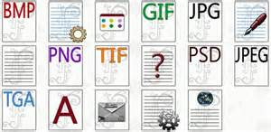

**File management**

File management involves the methods used once the work has been saved via disk or USB. I am going to be explaining some methods that are used by users and they are the following:

* **Naming files** - simply means giving your file a name so next time you know which file is saved. It will not be confusing if you name it yourself such as BTEC work, I name it P1, therefore I know which pass criteria it is.
* **Folder structures –** Folder structures are used to know where you’re file is kept. If you structure your folders, you would know where everything is kept. It would be more organised. For example, I put the Units name on each folder so I know which folder I open to work on.
* **Moving files –** Moving files involve dragging the file from the current place to another place. Some people can keep a copy of files from one part to another. Therefore, they have to drag the file that they want to copy to the selected part they want it to be.
* **Deleting files** – Deleting the file means that you remove it off the computer so that you do not need it anymore. Therefore, it cannot be used on the disk/USB again.
* **Compression techniques –** Compression techniques are used in files or image that reduce quality or does not reduce quality when used. The two types are called lossy and lossless compression.

**Lossy:**

Lossy compression is when you extract certain amount of information within a file that are not needed. Lossy compression is mostly used in likes of ‘BMP’ (Bitmap Image File). Any image loses quality depending on the compression (low, medium or high). This is used in media such as images. Another file that uses lossy is ‘JPEG’.

**Lossless:**

Lossless is a type of compression which doesn’t lose any data when reducing the amount of data. Lossless clamps all information into a 'more modest packs' or into a littler document measure by inside shorting the information. Case in point if a record size was initially 2(MB) lossless squeezing can decrease the document size into and a large portion of 1(MB) however anyway it relies on upon the document broadening on the off chance that it might be compacted effectively. Lossless packing is exceptionally valuable when using up space or attempting to spare. A great illustration of lossless layering programming might be 'WinZip'. WinZip utilizes lossless squeezing which packs things like projects features, writings, pictures, and so on which this is one of the reasons why numerous machine clients have a tendency to utilize this requisition when packing their records.

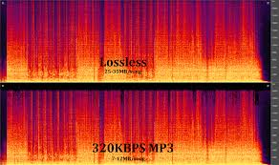

**Graphic Images**

**Vector Graphics**

Figure 1.1

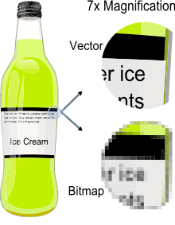Vector is a graphic computer image that it is a scale of quality when it has been enlarged. When it is enlarged, users are focused on the vectors of the image e.g. paths, strokes. It does not lose quality when the image has been enlarged. Referring to the figure 1.1, it shows when you enlarge the image of the bottle. Vector images come out clear whereas Bitmap images does not become clear when it is enlarged. Comparing vector images to ‘JPEG’, ‘GIFs’ and ‘BMP’, it does not contain grid pixels, but it can be different as paths, strokes and curves.

**Bitmap graphics**

As said before, bitmap is a graphic compute image that uses pixels (tiny blocks), because when the image is enlarged, unlike vector graphics, it loses quality. Bitmap graphics can be used on where pixel display is common e.g. CCTV cameras. It is not HD quality, but has pixels like bitmap to be used to create a bitmap display. Referring to figure 1.1, it demonstrates how bitmap image looks like. When it is enlarged, it shows us the pixels. Unlike bitmap, vector images are clear.

**Comparisons**

|  |  |  |
| --- | --- | --- |
|  | Vector | Bitmap |
| File size | Small | Large |
| Scaling | Any size | Pixilation occurs |
| File format features | JPEG | PNG |
| Typical uses | Diagrams | Photographs |